


Divine Word University
Faculty of Business & Informatics
Dept. of Mathematics and Computing Science

Computer Science System Design Specification
INTELLECTUAL AUDIT PLANNING AND RISK ASSESSMENT SYSTEM FOR NCDC
Intelligent Audit Planning System (IAPS)

Jerry LELUMAI
Year 4 Student
Bachelor of Mathematics and Computing Science
2026

Supervisor(s):
Mr. Lyall DALE
Head of Department (HOD)
Department of Mathematics and Computing Science
Faculty of Business & Informatics
Divine Word University

Table of Contents
Table of Contents 1
- Introduction 2
  - Project Description 2
- Software Requirements Specification 2
2.1. Function Requirements 2-3
2..2. Non-Function Requirements 3
3. Software Analysis & design 4
3.1. User Interface 4
3.2. Entity Relationship Diagram 4
3.3. Data Flow Diagram 4
3.4. Use Case Diagram 4-5
3.5. Class Diagram 5
3.6. Sequence Diagram 5
- Development and Implementation 5
4.1. Database 5
4..2. Backend Logic 5
- Testing and Validation 5
5.1. Unit Test 5
5.2. Integration Test 5
5.3. System Test 5
5.4. User Test 6
- Deployment 6
6.1. Deploy Application 6
- Conclusion 6

- Introduction
  - Projection Description

The Natonal Capital District Commission (NCDC) is a local government authority that deals with larger number of financial transactions that requires efficient and proper auditing to ensure accountability, transparency and compliance with laws and regulations. The risk assessment and audit planning are crucial phase in the auditing process. By providing foundation for a successful audit. These processes help auditors to understand the clients, set an overall strategy, and reduce audit risk by focusing time and resources on key areas of potential misstatement.

The Intelligent Audit Planning System (IAPS) aims to improves auditing processes (specifically the risk assessment and planning phase) within NCDC by integrating advance technologies like Machine Learning (ML) and Multimodal Large Language Models (MLLMs) and Optical Character Recognition (OCR) for information mapping, risk assessments and planning analysis, and Web-based interface for user interaction and output presentation. The key features mainly focus on the client intake and management, engagement acceptance and independent checklist, financial data upload and management, planning analytics, materiality calculator, internal control assessment matrix, risk assessment and scoring engine, AI-powered audit procedure recommendation, workpaper generator, evidence management, task management and review sign-off, interactive risk dashboard, audit planning management, secure user authentication and role management, and reporting and export.

The system improves efficiency, consistency, and documentation quality while keeping professional judgement with the auditor. Importantly, IAPS provides a practical, scalable foundation for future intelligent audit tools while supporting digital transformation in auditing and strengthens governance, particularly for public sector organizations in Papua New Guinea.

- System Requirements Specifications
  - Functional Requirements
According to Systems Analysis and Design in a Changing World, functional requirement describes “the activity that the system must perform to support business process (Satzinger, Jackson and Burd 2016). The explained list of main features the system must provide, group by the module:
- User Management
This feature supports secure access to the system by login and two factor authentication. The role, auditors to perform all the necessary functionality and supervisor to assess, make comments on the output (review and sign-off).
- Engagement Management
Enables the auditors to create/view engagement with different stakeholders, store client details and year.

- Data Collection
This module caters for uploading of trial balance/financial statement (CSS/Excel), entering internal control information and capture interview notes.
- Planning Analytics
Performs the ratio, trend, and variance analysis and displays the output in table or charts.
- Materiality calculation
This module outlines the test used to measure and compute materiality and materiality performance.
- Internal Control Assessment
The internal control assessment supports records of internal controls (IC) and capture the design, implementation and rate IC effectiveness.
- Risk Assessment
The system will allow the auditor to enter Inherent Risk and Control Risk for each account or process, then calculate the Risk of Material Misstatement (ROMM) and highlight high-risk accounts on the dashboard. This is important because it shows the auditor where the chances of errors are highest so they can focus their work there.
- AI-assisted Planning
The system will connect to the OpenAI API to generate draft planning memorandums, summarize interview notes, and suggest audit procedures. The auditor can review, edit, and approve these drafts before using them. This helps save time on writing and gives useful ideas, while still keeping the final decision with the auditor.
- Document Management
The system must allow users to upload, store, and open planning documents and evidence such as engagement letters, financial statements, and risk assessments. This is important because keeping all documents in one secure place makes the audit easier to manage and review.
- Dashboard and Reporting
The system must show dashboards that display engagement status, materiality, risk overview, and progress of planning tasks, and it must be able to generate planning reports. This matters because dashboards and reports give a clear picture of the audit planning situation and help supervisors monitor the work.
- Audit Trail
The system must record important actions, such as data uploads, changes in risk ratings, and approvals of documents, along with user and time information. This is important because it creates a clear history of what was done, which supports accountability and good governance.

  - Non-Functional Requirements
- Performance
The system should respond quickly to normal user actions, such as opening dashboards, saving forms, and running analytics for a typical audit engagement. Users should not have to wait a long time for pages to load or calculations to finish. Good performance is important because slow systems frustrate users and may discourage them from using the system during busy audit periods.
- Security
The system must protect sensitive financial and audit information. Users should log in with secure usernames and passwords, and different roles (such as auditor or supervisor) should only see and change what they are allowed to. All data sent between the user’s browser and the server should be encrypted using HTTPS. Strong security is important because audit planning involves confidential data that must not be exposed or changed by unauthorized people.
- Reliability
The system should work consistently and handle problems without crashing. If a user uploads an incorrect file or the AI service is temporarily unavailable, the system should show a clear error message and let the user try again, instead of failing silently or losing data. Reliability is important because auditors must be able to trust the system when planning important work.
- Usability
The system should be easy to use, even for auditors who are not technical. The web pages should have clear labels, simple menus, and a logical flow that matches the audit planning stages (Upload Data, Analytics, Controls, Risk, AI Outputs, Documents). Helpful messages and validations should guide users when they make mistakes or leave fields blank. Good usability is important because it reduces training time and helps users do their work quickly and accurately.

- System Analysis and Design
  - User Interface
The user interface of the Intelligent Audit Planning System (IAPS) is designed as a simple, web‑based application that auditors can access through a browser. The main screens include a login page, an engagement list page, and an engagement details page. Within each engagement, the interface is divided into tabs that follow the audit planning phases: Data Upload, Analytics, Internal Controls, Risk Assessment, AI Outputs, and Documents. A dashboard page provides a summary of materiality, key risk areas, and planning progress using charts and status indicators. Navigation is kept consistent across the system, with clear labels and buttons so that auditors can move easily between phases without confusion. Forms use straightforward input fields, validation messages, and hints to guide the user, making the system easy to learn and use.

  - Entry Relationship Diagram
The Entity Relationship Diagram for IAPS shows how the main data entities are connected in the database. Core entities include User, Client, Engagement, FinancialData, Control, RiskAssessment, AIOutput, and Document. A Client can have multiple Engagements because an organization may be audited for different periods or projects. Each Engagement is linked to many FinancialData records (such as trial balance entries), many Controls (documenting internal control activities), many RiskAssessments (for accounts and processes), many AIOutputs (draft memorandums and recommendations), and many Documents (uploaded files like engagement letters and financial statements).

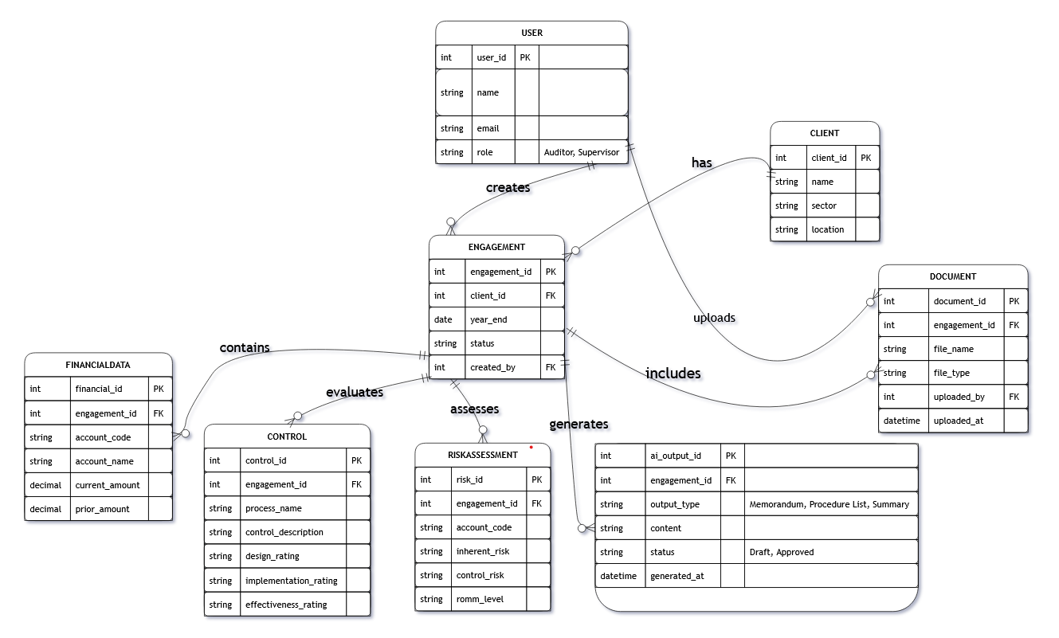
The User entity is associated with actions such as creating engagements, uploading data, and approving AI documents, providing traceability. This ERD structure ensures that all planning information is organized around the engagement, which is the central unit of work in an audit.

Figure 1. Show the Entity Relationship Diagram for the proposed system.

  - Data Flow Diagram
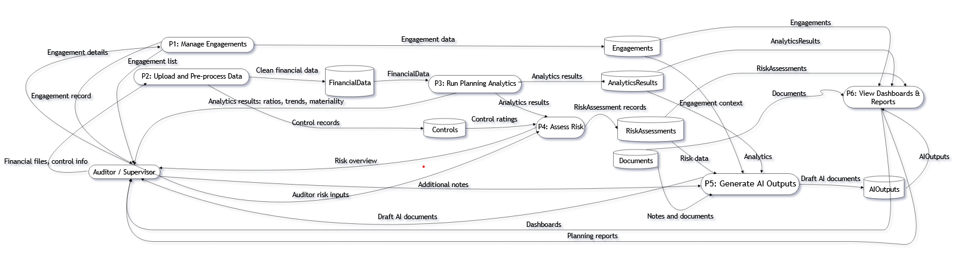
The Data Flow Diagram describes how information moves through the system from input to output. At a high level, the process begins when an auditor creates an Engagement and uploads financial data and control information. The system then pre‑processes the uploaded data, storing clean records in the FinancialData and Control tables. The analytics process reads this data to calculate ratios, trends, and materiality values, which are stored and displayed on the dashboard. The risk assessment process uses the analytics results and control assessments to capture and compute Inherent Risk, Control Risk, and ROMM, updating the RiskAssessment records. When the auditor requests AI‑assisted planning, relevant data and notes are sent to the AI service, which returns draft outputs stored in the AIOutput entity. Finally, the dashboard and reporting processes read from all these entities to present summaries, charts, and planning reports to the user. This flow ensures that data is processed in a logical sequence and reused efficiently across the system.
Figure 2. Shows Data Flow Diagram that describes how information flows through the system.

  - Use Case Diagram
The Use Case Diagram for IAPS shows how different types of users interact with the system. The main actors are the Auditor and the Supervisor. The Auditor can log in, create new engagements, upload financial data, record internal controls, perform planning analytics, assess risks, request AI‑generated planning memorandums, and upload or view documents. The Supervisor can log in, review engagements, examine dashboards and reports, review AI outputs, and approve or sign off on planning documents. Each of these actions is represented as a use case linked to the appropriate actor. By mapping these use cases, the diagram clarifies what functionality the system must support to meet user needs and ensures that both auditors and supervisors have the tools required to complete and review the audit planning phase.
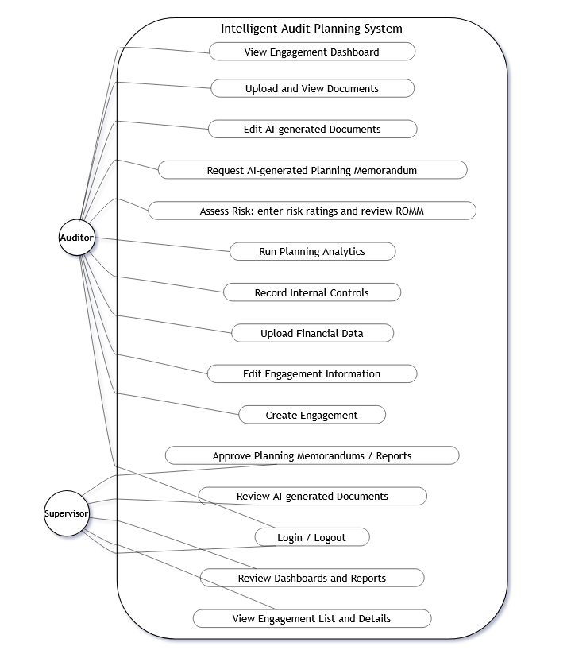
Figure 3. Use case diagram show the activities between the users and the system.

  - Class Diagram
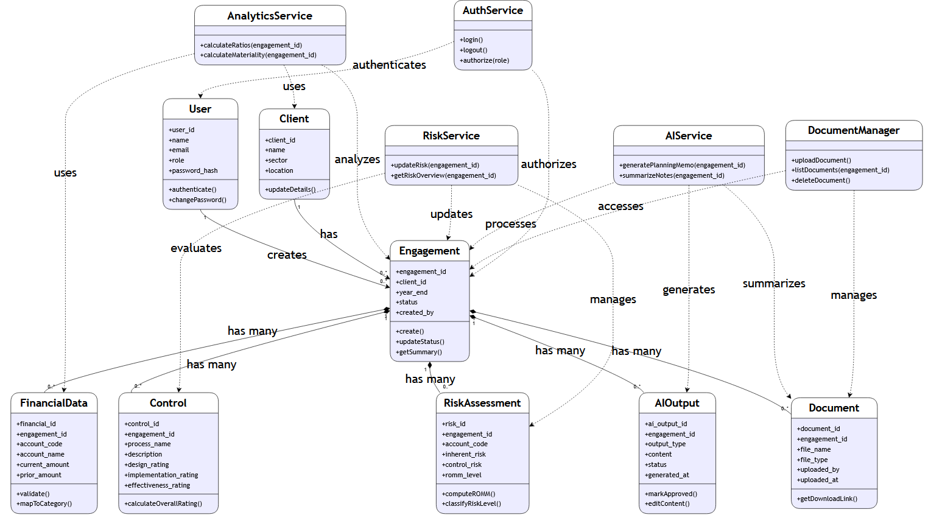
The Class Diagram describes the main software classes and their relationships in the backend design of IAPS. Core domain classes include User, Engagement, FinancialData, Control, RiskAssessment, AIOutput, and Document, each representing a table or entity in the system. AnalyticsService, RiskService, AIService, DocumentManager, and AuthService are service classes that handle business logic. For example, AnalyticsService contains methods to calculate financial ratios and materiality, while RiskService includes methods to compute ROMM and rank accounts by risk level. This class structure supports a modular and maintainable implementation.
Figure 4. Class Diagram describes the main software classes and their relationships with the backend.

  - Sequence Diagram
The Sequence Diagram illustrates the order of interactions between the user interface, backend services, database, and AI service in key scenarios.

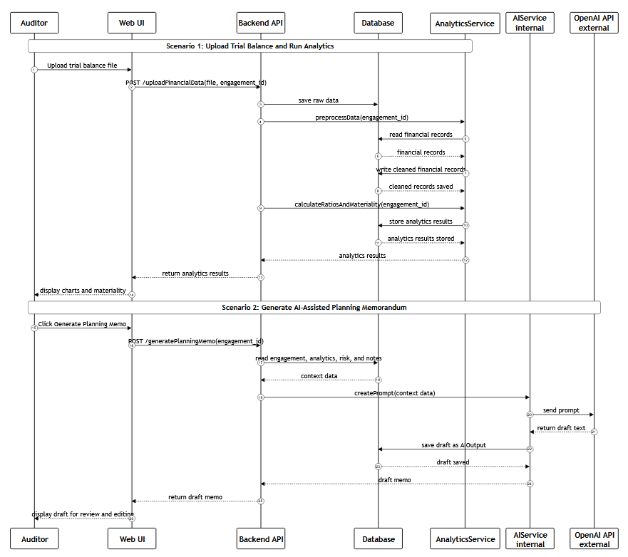
Scenario: “Generate AI‑assisted planning memorandum”: the Auditor clicks a button on the AI Outputs tab, the frontend sends a request to the backend, which collects relevant data and notes from the database, sends them to AIService, calls the Docling, receives draft text, stores it as an AIOutput record, and sends it back to the frontend for the auditor to review and edit. By showing each step and message in order, the sequence diagrams help ensure that all components work together correctly and that the system’s behavior is clearly understood before implementation.
Figure 5. Sequence Diagram illustrates the order of interactions between the user interface, backend services, database, and AI service in key scenarios.

- Development and Implementation
  - Database
  - Backend Logic
- Testing and Validation
  - Unit Test
  - Integration Test
- Deployment
  - Deploy Application
- Conclusion

